Lesson 04 Demo 11

Managing Containers with Azure Container Apps

Objective: To manage container with Azure container apps
Tools Required: Azure account with administrator access

Prerequisites: None

Steps to be followed:
- Manage container with Azure container apps

Step 1: Manage container with Azure container apps

- Search for and select Container Apps after signing in to the Azure portal

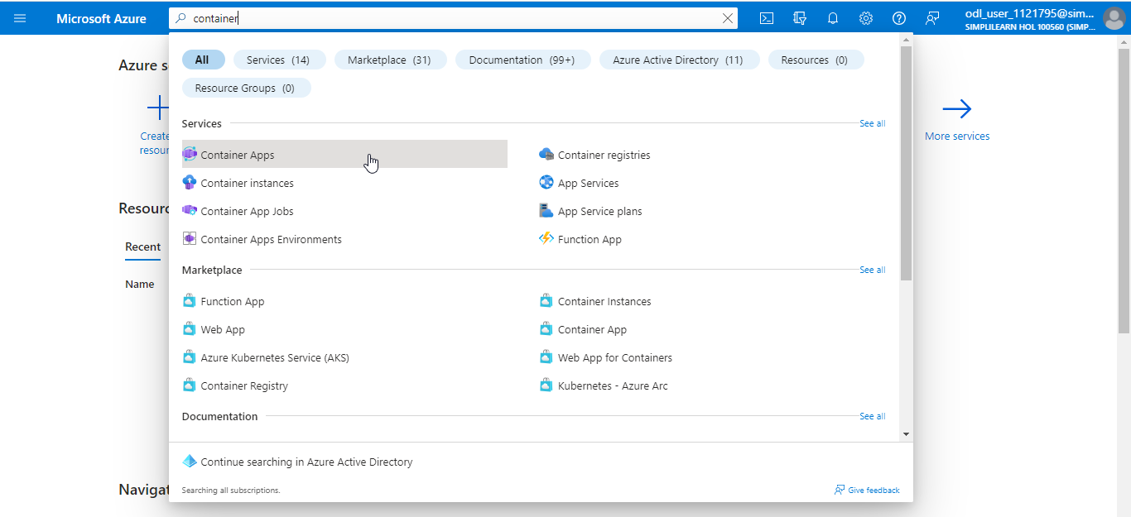

- Click on + Create

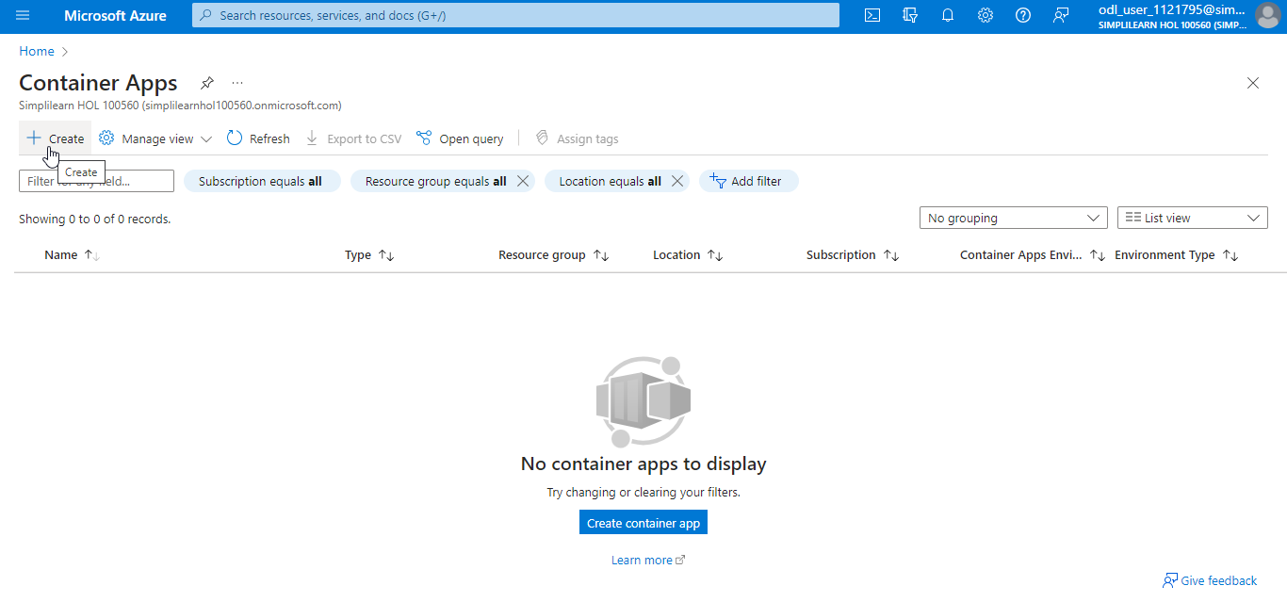

- In the Create Container App page, navigate to the Basics tab. Click Create new to create a new Resource group, then enter the remaining details as shown in the screenshots below:

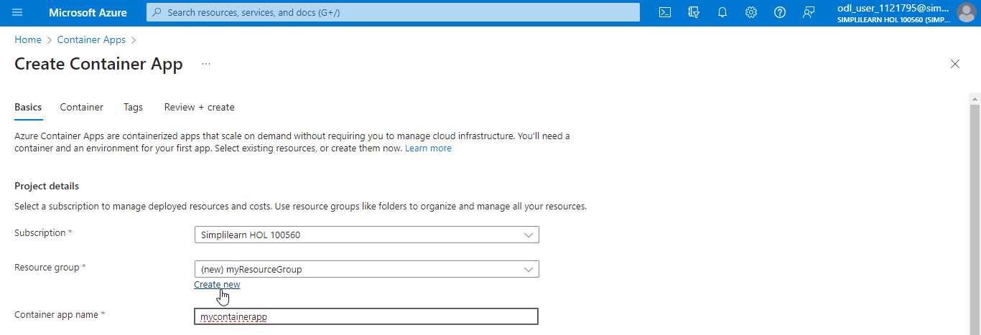

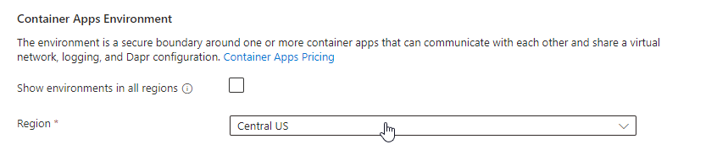

- Under Container Apps Environment, click on Create new

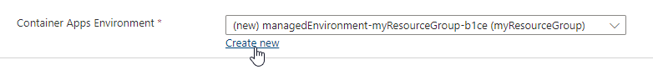

- In the Create Container Apps Environment page, navigate to the Basics tab and provide the details as shown in the below screenshots:

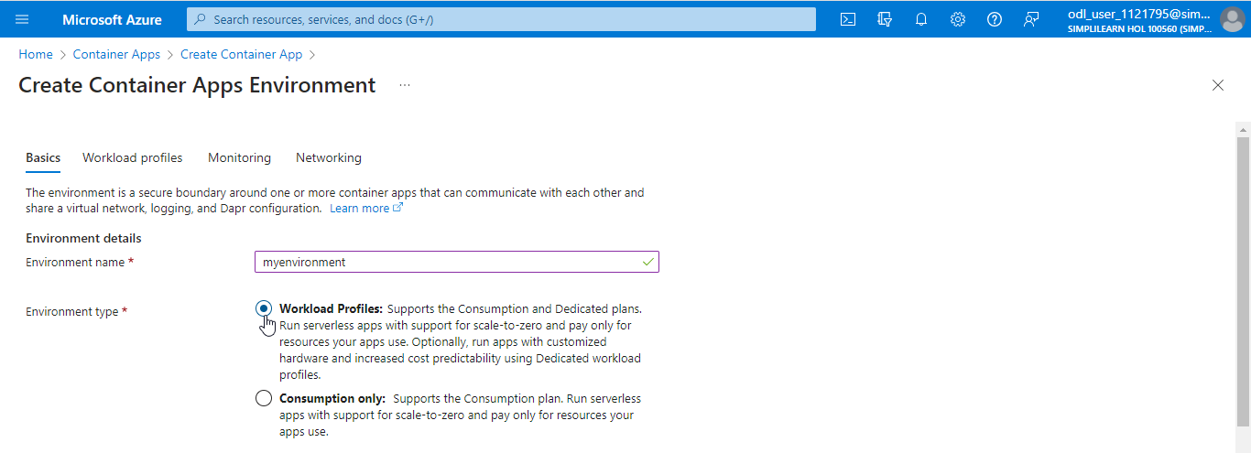

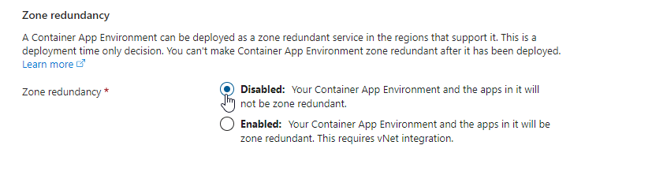

- Navigate to the Monitoring tab

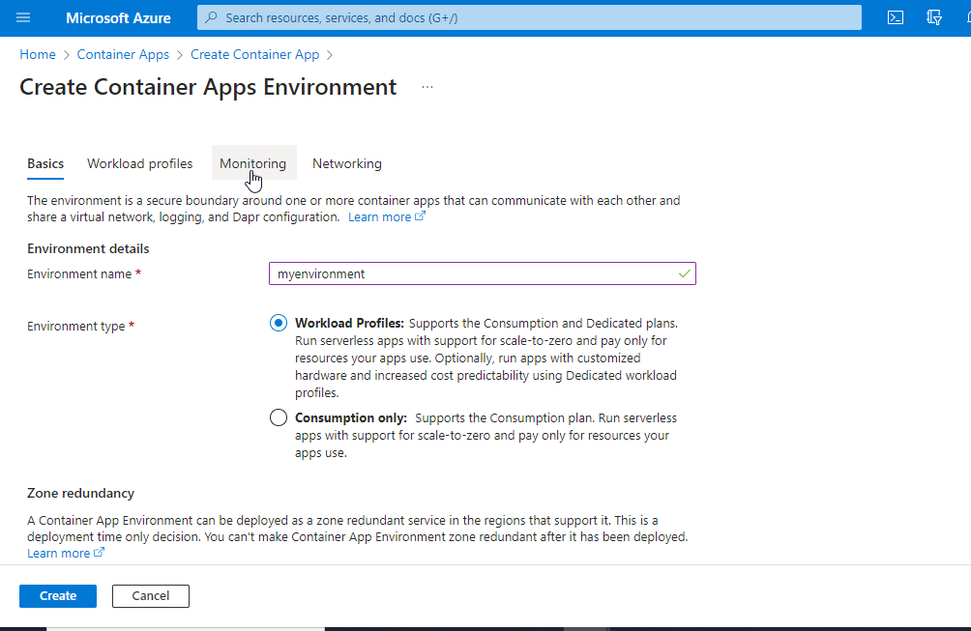

- Under Log Analytics workspace, click on Create new. In the Create new Log Analytics Workspace section, enter a Name and click on OK.

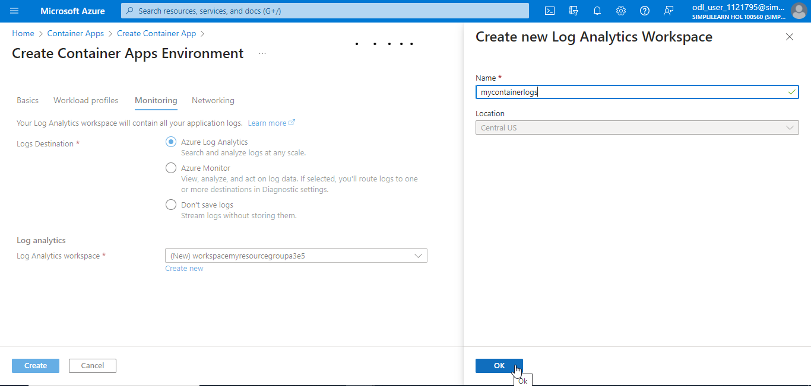

- Click on Create

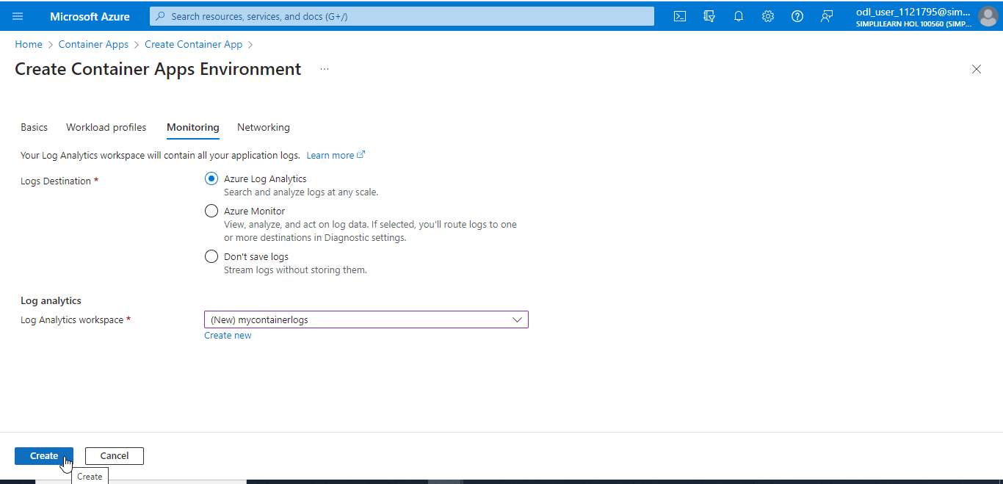

- Click on Review + create

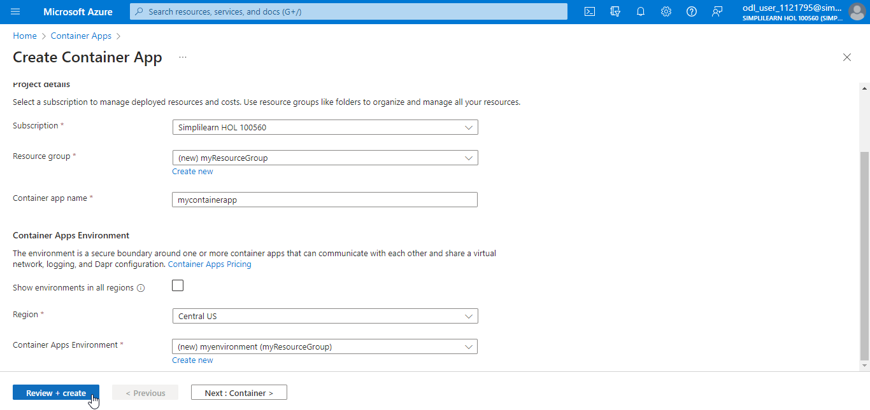

- After the validation is passed, click on Create

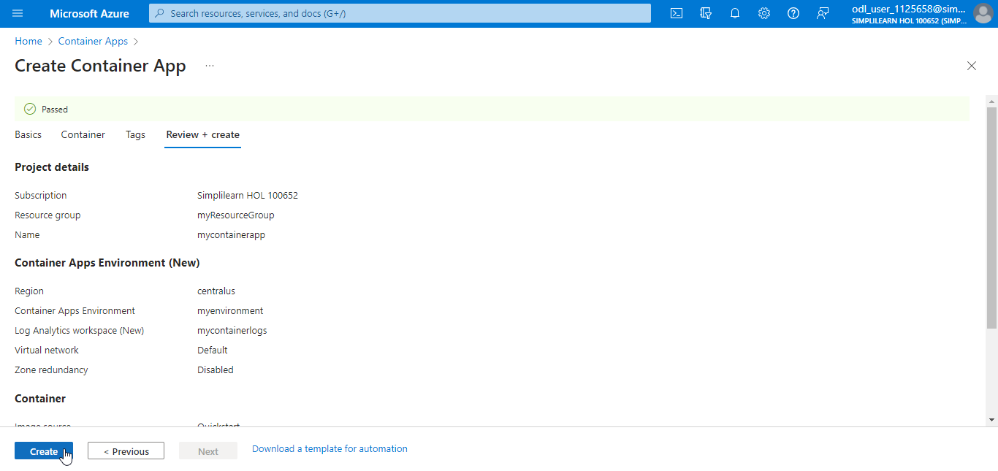

The container app is created successfully.

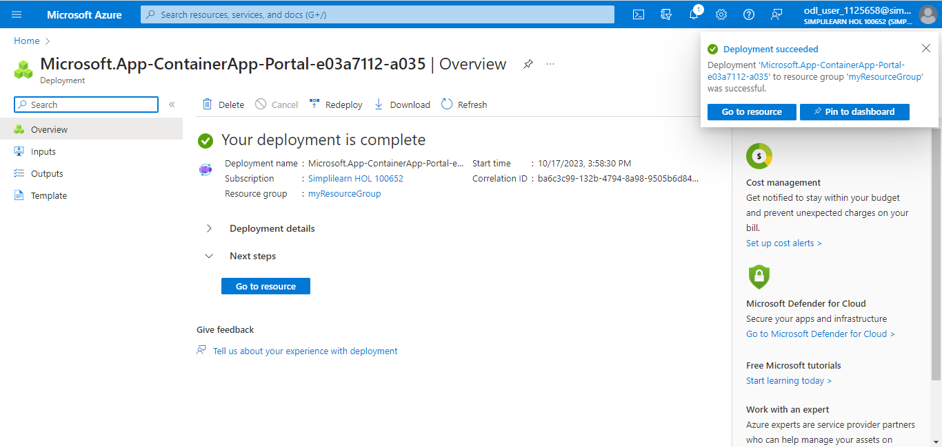

- Navigate to the created container app on the Container Apps page

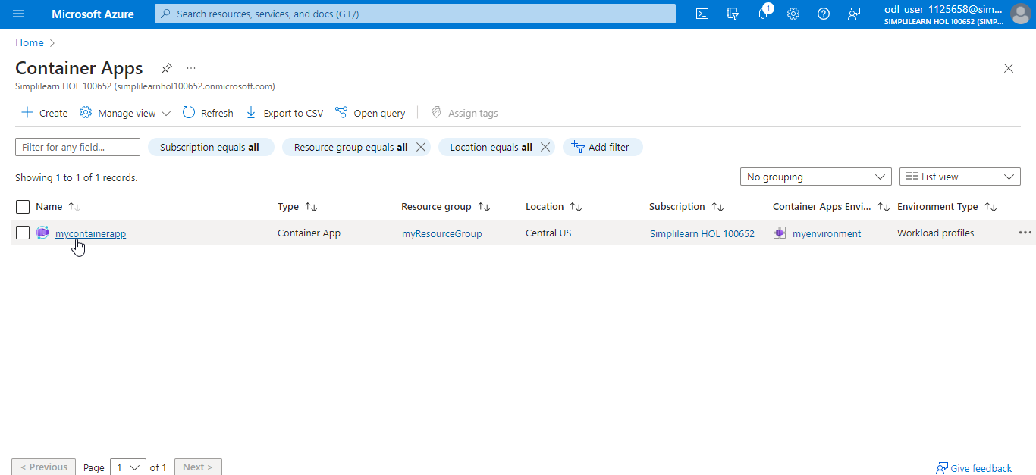

- Click on the application URL to view the container app

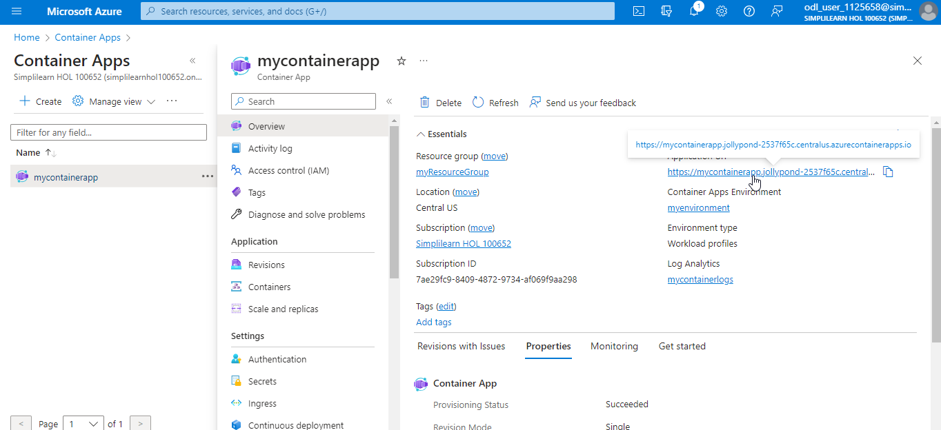

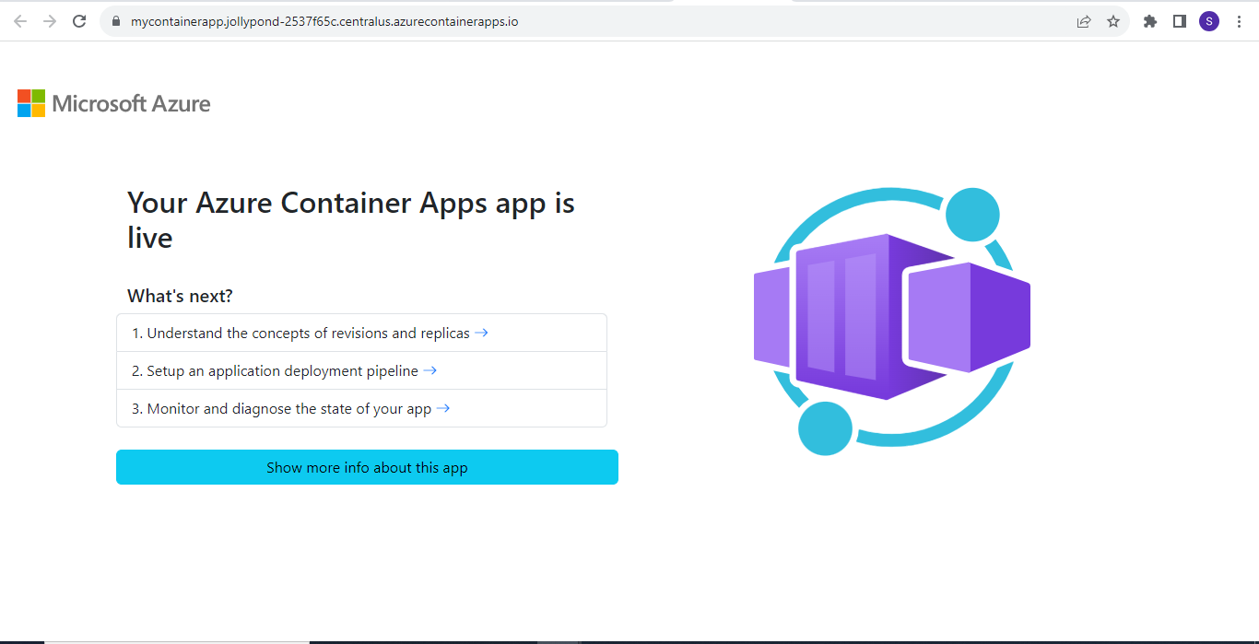

With this, you have successfully set up and configured your environment to manage containers with Azure Container Apps.

